### 3 ingrédients:

1. Proba a priori:
   1. info ad hoc fourni par l’expert
   2. info que l’on peut estimer
   3. pas d’info ⇒ équiprobabilité
2. Vraisemblance: Approcher les valeur par une loi gaussienne multidimensionnelle

| données | x ∈ IR | X ∈ IRp |
| --- | --- | --- |
| Moyenne | {"backgroundColor":"#ffffff","type":"$$","code":"$$u\\,=\\,\\frac{1}{n}\\sum_{i\\,=\\,1}^{n}x_{i}$$","font":{"color":"#000000","family":"Arial","size":11},"id":"1","aid":null,"ts":1667834661839,"cs":"nb/ystv6VtL8SykmQ6BqsQ==","size":{"width":100,"height":44}} | {"backgroundColorModified":false,"code":"$$m\\,=\\,\\left[\\frac{1}{n}\\sum_{i=1}^{n}X_{i},\\,...,\\,\\frac{1}{n}\\sum_{i=1}^{n}X_{p}\\right]∈\\,\\mathbb{R}^{P}$$","type":"$$","id":"2","backgroundColor":"#ffffff","aid":null,"font":{"color":"#000000","size":11,"family":"Arial"},"ts":1667834793334,"cs":"wjd50ELInZHxYBn2E50fjw==","size":{"width":289,"height":50}} |
| Variance | {"id":"3","backgroundColor":"#ffffff","type":"$$","font":{"size":11,"color":"#000000","family":"Arial"},"backgroundColorModified":false,"code":"$$\\alpha^{2}\\,=\\,\\frac{1}{n}\\sum_{i=1}^{n}\\left(x_{i}\\,-\\,u\\right)^{2}$$","aid":null,"ts":1667834850120,"cs":"gIdDMuoJrXio2T8jcGwtrw==","size":{"width":164,"height":44}} | {"aid":null,"font":{"size":11,"color":"#000000","family":"Arial"},"id":"4","type":"$$","code":"$$\\sum_{}^{}\\,=\\,\\frac{1}{n}\\,X_{C}^{T}X_{C}$$","backgroundColor":"#ffffff","backgroundColorModified":false,"ts":1667834881899,"cs":"6gvEqD+wBNo00Yqyovw4/w==","size":{"width":124,"height":34}} |

1. Règle de Bayes

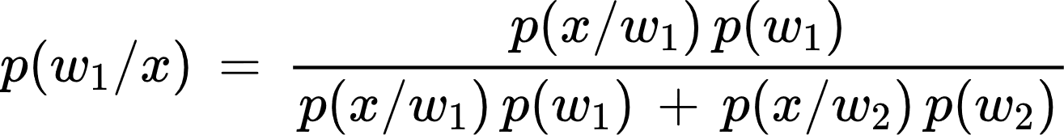

### Exercice 1 : Gaussienne dans IR

1. 61% d'observation ≥ 60

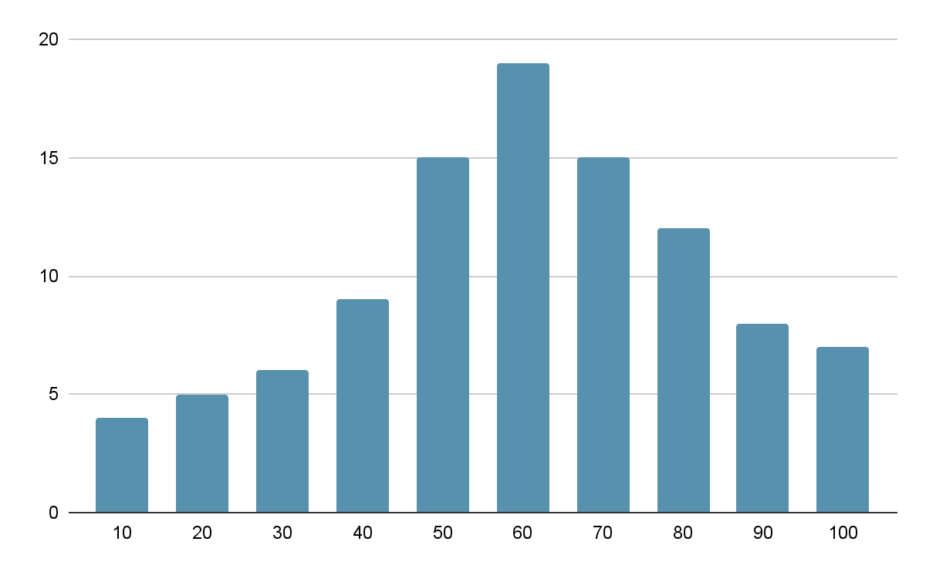

{"backgroundColor":"#ffffff","backgroundColorModified":false,"type":"$$","font":{"size":7.5,"color":"#000000","family":"Arial"},"code":"$$u\\,=\\,\\frac{1}{100}\\left(4*10\\,+\\,5*20\\,+\\,6*\\,30\\,+\\,9*\\,40\\,+\\,15*50\\,+\\,19*\\,60\\,+\\,15*70\\,+\\,12*80\\,+\\,8*90\\,+\\,7*100\\right)\\,=\\,60$$","aid":null,"id":"6","ts":1667835841230,"cs":"wn6Yn8WmuMqlXmucKjf7ig==","size":{"width":601,"height":25}}

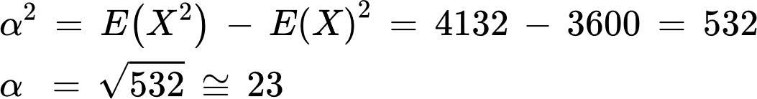

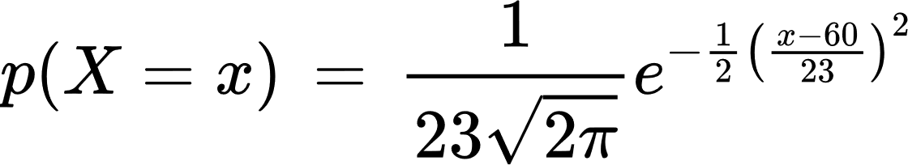

1. 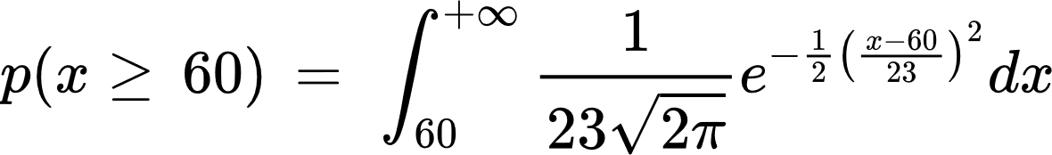

### Exercice 2 : Loi Gaussiennes

#### Q1.

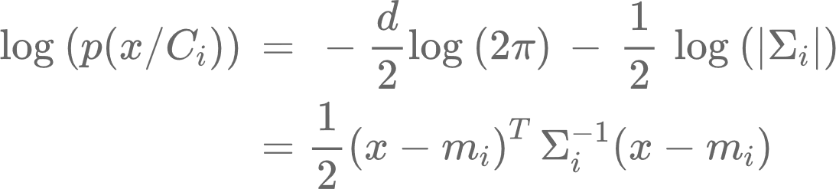

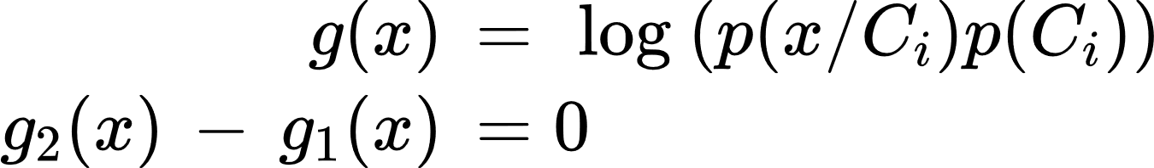

#### Q2.

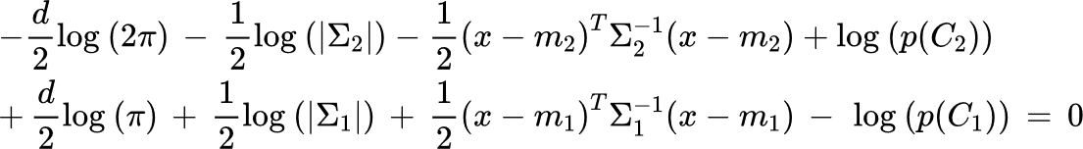

Si 

{"id":"14","font":{"size":11,"color":"#000000","family":"Arial"},"backgroundColorModified":false,"type":"$$","backgroundColor":"#ffffff","code":"$$\\left(x-m_{2}\\right)^{T}\\Sigma^{-1}\\left(x-m_{2}\\right)\\,=\\,\\left(x-m_{1}\\right)^{T}\\,\\Sigma^{-1}\\left(x-m_{1}\\right)$$","aid":null,"ts":1667837900352,"cs":"69lfokdQst4Ykk/DgADoFw==","size":{"width":369,"height":20}}

#### Q3.



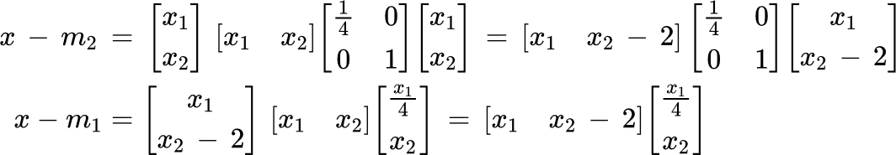

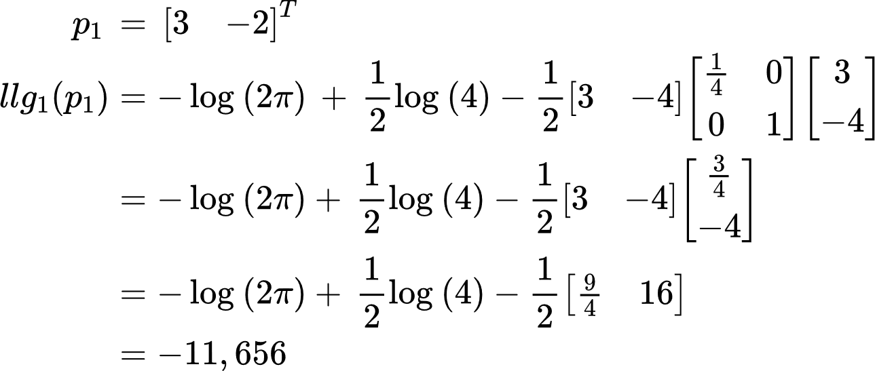

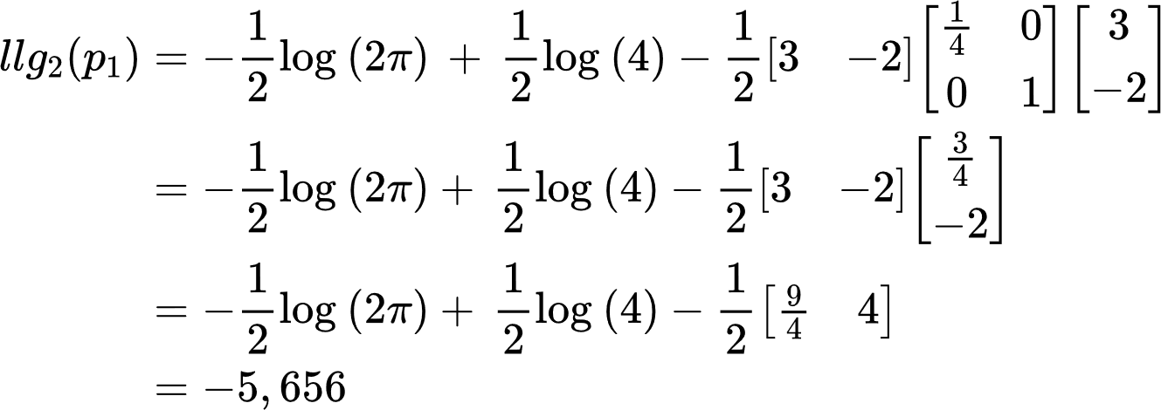

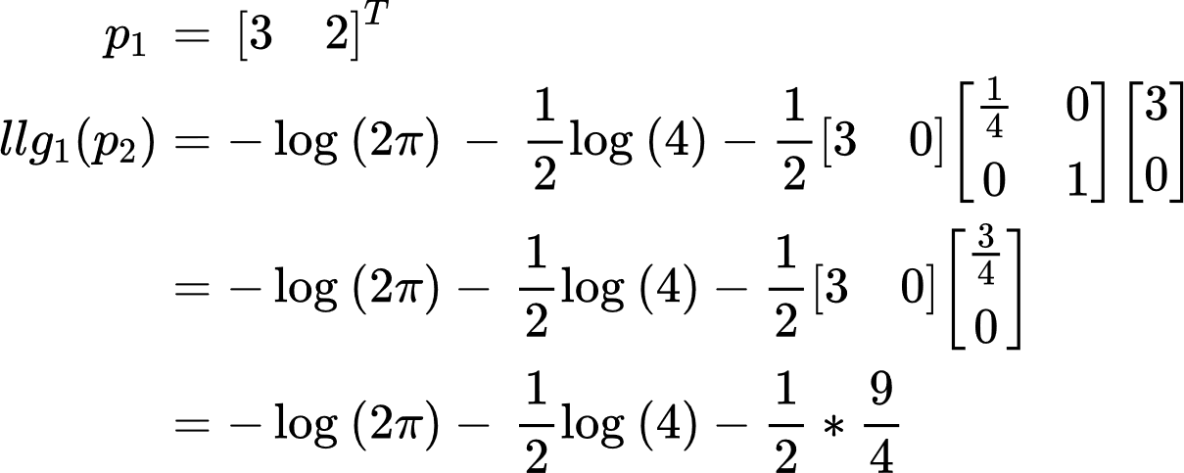

#### Q5

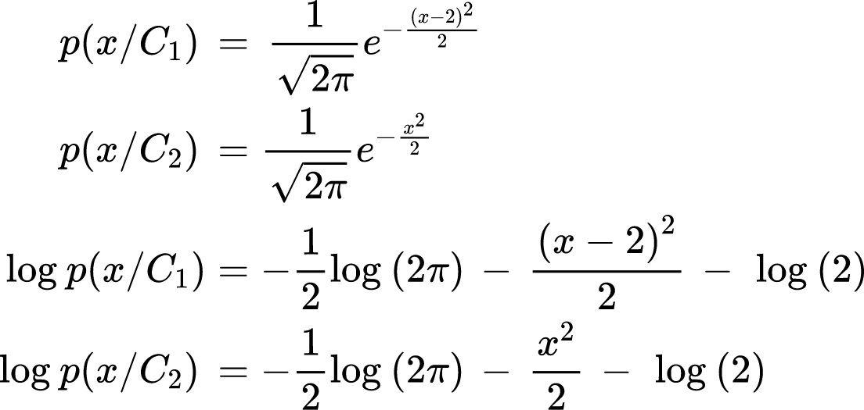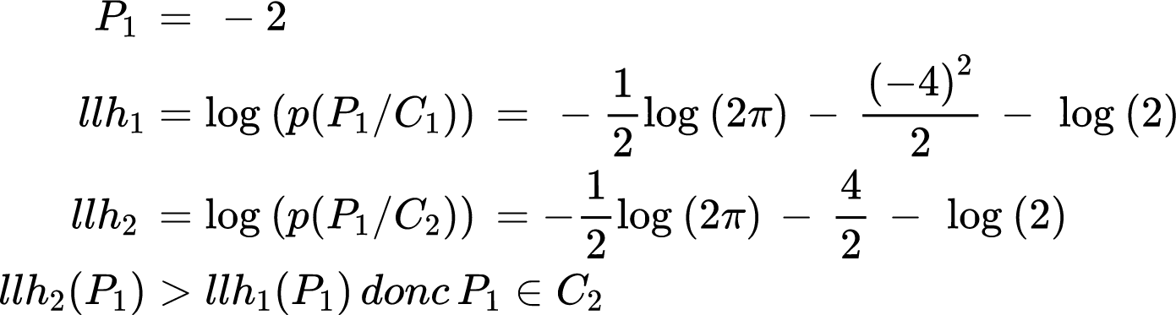

### Exercice 3: Classification Bay ́esienne avec des distributions de Rayleigh

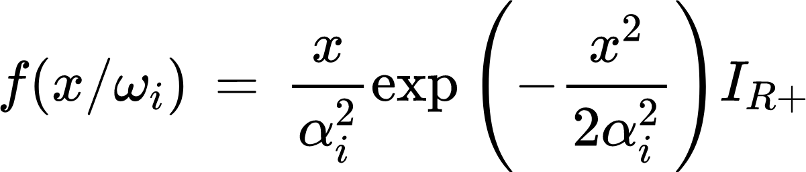

Règle de bayes: x ∈ w1 si 

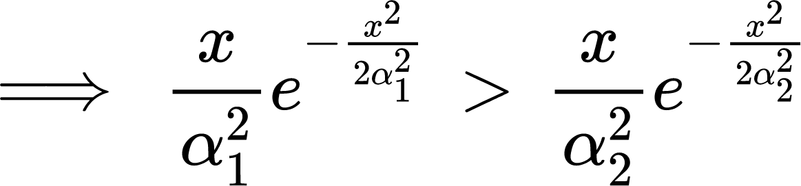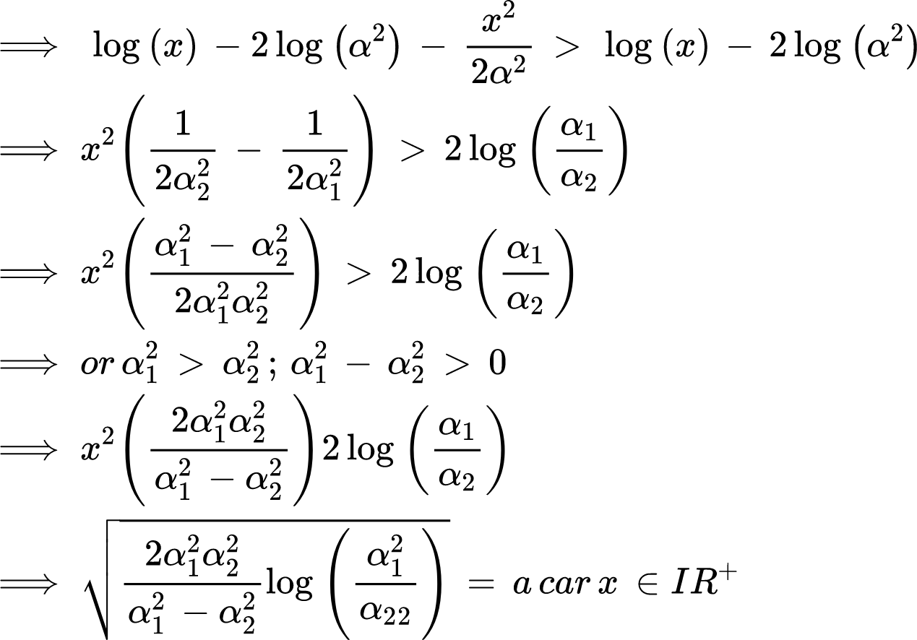

on note d(x) = w la décision que x ∈ w1

